You Be The Judge with Robert Cole
This article was written by Robert Cole, and was first published in Dog News. It was available online at the WorldClassDogs website, but that site is no longer available. This issue was found using the archive.org website, and I feel the information is still valid and should be available for us to learn from. Robert Cole is an amazing author and artist, and I recommend you read his book "An Eye for a Dog: Illustrated Guide to Judging Purebred Dogs"
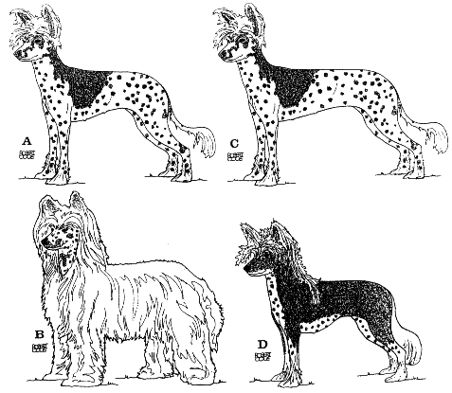
Select
Select a first, second and third in this class of four Chinese Crested bitches, that is unless you have read and agree with the 1991 AKC official description of ideal Chinese Crested height-to-body length ratio. In that case select four placements and put very long bodied Bitch C first.
Varieties
Crested come in two varieties: Hairless and Powderpuff. The two varieties are structurally identical but visually quite different. They must be interbred because the Hairless is the result of an incomplete Dominant mutation which is lethal when homozygous (carrying only the hairless gene). Puppies carrying only the hairless gene have abnormalities so severe that few are born alive and those that are do not survive. Breeding Hairless to Hairless without ever introducing the Powderpuff gene into a line can result in toothless, baldheaded dogs with poor bone structure. [Note from Curlious: This statement about HL to HL breeding is incorrect, and was a myth used to help promote using the powderpuff in breeding programs, which many breeder's didn't like. Because of their lack of understanding of the genetics involved, they believed this myth.]
Type
The 1991 American Standard reduced the 1986 British Standard's requirement for two distinct types, i.e. Deer type and Cobby type to just one type. Although Canada uses the older, two-type British Standard I, like many Canadians, am in favor of the "one type" American wording. Be that as it may, a number of British and Australian readers have written to say they preferred the type that I gave last place to in an earlier version of this illustrated treatise. This preference for a type other than the one I believe Americans describe as ideal has caused me to look more closely at the "other" type and has ensured that I provide you with the same opportunity to choose between the two real-life, differently structured Hairless types that readers of the earlier version had.
However, before you choose between Hairless Bitches A and D in terms of type, I would like to point out that these two do not represent true Deer and Cobby types as was rightly pointed out to me by an Australian breeder. These two bitches depict intermediate types that tend towards Deer or tend towards Cobby. Both are British champions. Each has its own particular appeal and following in Britain and I suppose in Canada, however currently in Canada I see a trend towards one type, the type the AKC describes.
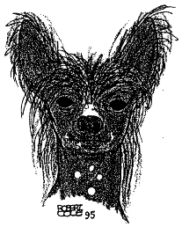
Head
Type is also greatly dependent on the head. These four bitches have good heads however their three-quarter head angle doesn't fully convey this breed's elegant magic in the way that the separate Hairless head that I have drawn face-on does.
Face-on, the base (lobe) of this bitch's erect ears are correctly level with the outside corner of her eye, an ear position not readily appreciated except face-on. Her skull under the crest arches gently over the occiput from ear to ear. Her dark almond shaped (AKC) matches her dark coat coloring. Her nose is completely dark, lighter (AKC) in lighter colored Cresteds. She has clean, tight lips; a length of muzzle equal to length of skull; and under the crest a slight but distinct stop.
Her teeth are a complete scissors or pincer (AKC) bite. Complete dentition in the Hairless variety is deserving of special praise. Full dentition is found in the Powderpuffs but less often in the Hairless, an inequality selective breeders have recently overcome. [Note from Curlious: This isn't completely true, teeth are made up genetically from the same stuff as hair, and the gene that makes our cresteds hairless also modifies their teeth. The number of teeth in a HL isn't a major consideration, as long as the bite is correct.]
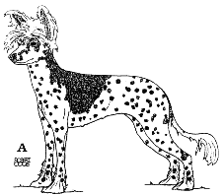
Bitch A
This Chinese Crested has long, straight, slender forelegs, longer than her body is deep. Her elbows are held close to her body and level with deepest part of brisket. She is 13 inches (33 cm) at withers, and is slightly longer in body (rectangular) measured from point of forechest to buttocks than height. Her neck is long, lean and free of throatiness, sloping into laid back shoulders. Her back is level, her tuck up is moderate, her rump well rounded and muscular, her hindquarter angulation is balanced with front, and her slender, plumed tail tapers to a curve. The sometimes misinterpreted British words "tail set high" are not included in the American Standard. This doesn't mean the tail is carried low at the trot. In addition to the British "carried up or out" the American words read "the tail is carried gaily and may be carried slightly forward over back."
She has hair on her head (crest), the tail (called a plume), and the feet from wrists to toes in front and from hock to toes in rear (called socks). The texture of the hair is soft and silky, flowing to any length. Placement of hair is not as important as overall type. Wherever the body is hairless the skin is soft and smooth and warm to the touch.
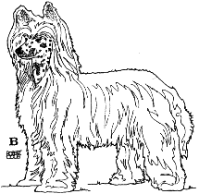
Bitch B
I have raised this British Powderpuffs ears up to conform to American preference for "erect" (in Britain drop ears are permitted on Powderpuffs and the effect is very charming.)
She stands 14 inches (35.6 cm), 1 inch (2.5 cm) over maximum for American bitches, 2 inches (5 cm) over the maximum for British bitches) because her steep forequarters and steep hindquarters have forced (raised) her body up above her elbow. This faulty relocation of the forequarters forward on the body and the steepness of the hind legs can be seen despite coat cover.
She is fine boned and slender but not so refined as to appear breakable or alternatively. not a robust heavy structure. Her neck is lean, clean and slightly arched. Her topline should be level but isn't. She should have a breastbone but not one that is prominent. Here is where the hands confirm that the elbow and brisket should meet but on this bitch do not. Hands should also confirm that the foot is a harefoot, narrow with elongated toes.
Powderpuff coats have improved a great deal since the British description was written. The more recent updated American description reads "...completely covered with a double soft and silky coat. Close examination reveals long thin guard hairs over a short silky undercoat. Excessively heavy, kinky or curly coat is to be penalized..."
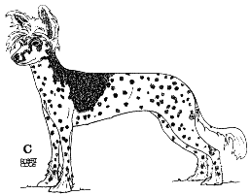
Bitch C
I included this very long bodied Hairless example as an illustrated suggestion to current writer-revisors of Breed Standards that they measure the body from the forechest to the buttocks, not from the withers to the base of the tail.
The body of Bitch C is real-life Bitch A depicted as the 1991 AKC inadvertently Standard advises: "Body length from withers to base of tail is slightly longer than height at withers." That makes the topline, say, 14 inches (35.6 cm) long on this 13-inch (33 cm) tall bitch, then we must add on the forequarters and forechest in front of the withers, say another 3 inches (7.5 cm). This combined 3 inches for forequarters and 14 inches for topline produces a Crested 13 inches tall and 17 inches long (43 cm).
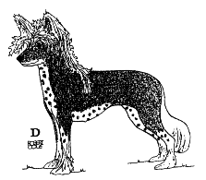
Bitch D
This 12-inch (30.5 cm) sound, tends-towards-Cobby type Hairless has almost the same length of body and depth of body as Hairless, Bitch A but is 1 inch (2.5 cm) shorter because her legs are 1 inch shorter. She doesn't appear to be heavier in body or bone. Her legs are average or moderate in length, the same length as her body is deep, whereas the long legs of Bitch A are longer than her body is deep.
Both British and American Standards call for long, straight legs. The legs of this tends- towards-Cobby type are not really long yet viewed by herself her appeal is readily apparent. This appeal is not lessened by her longer hair hence the British warning "Long and flowing Crest preferred, but sparse acceptable" and the American "Placement of hair not as important as overall type." Which overall type do you prefer?

Decision Time
The first decision is type. Type is between Bitch A and Bitch D. Both have appeal. I prefer Bitch A. Second decision is between sound Hairless Bitch D and less sound and of a different type Powderpuff Bitch B. I prefer sound Bitch D and if the coats were reversed I would still prefer Bitch D. If you prefer Bitch B's type over Bitch D's type and are willing to forgive this Powderpuffs unsoundness, that is your decision. However, if your preference for any award is based solely on coat, breeders are right to be concerned.
This article was first published in Dog News.
Copyright WorldClassDogs Inc 1996-1998
© 2011 Curlious Chinese Cresteds, All Rights Reserved

